**JAVASCRIPT**

# Web Application

## Client-server computer program runs on web browser.

## Web application will be installed on the web server.

## To access the web application, we should have browser in our client machine.

## And using that browser by passing the URL we can see all the data related to web application.(ie. Browser will interpret that data from web application and same data will be present to user).

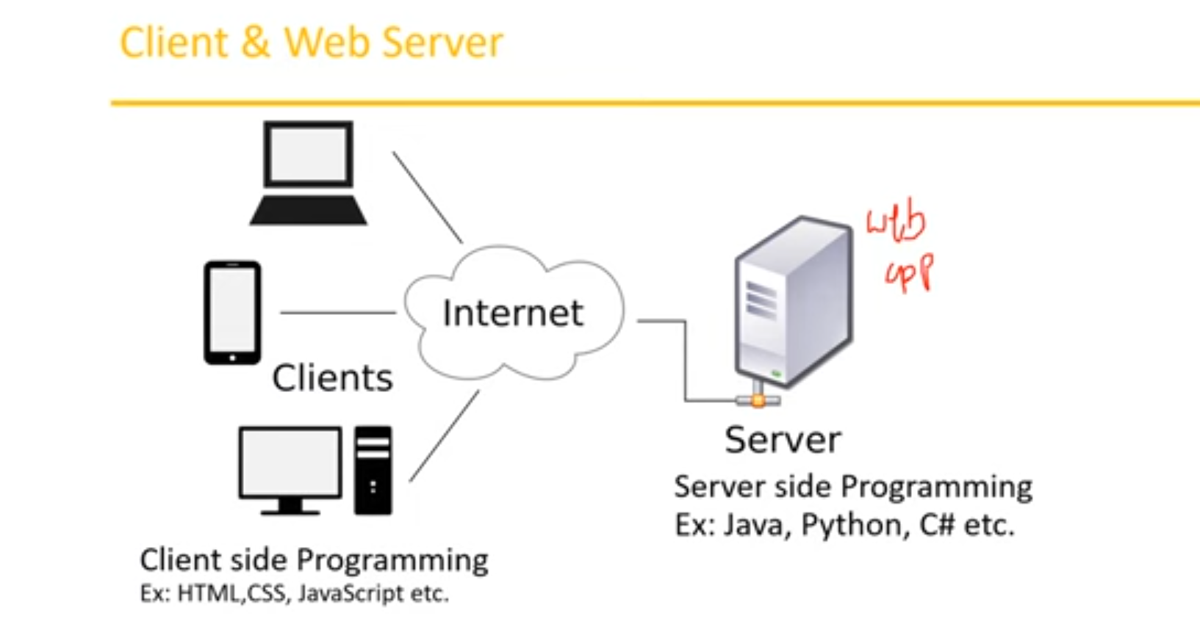

## **Browser**- Present data to User. Internally in browser the elements will be designed by HTML. Within the HTML we must include javascript.

## The programming we do at the server side we call it as server-side programming(java, python etc).

## To interpret the data from server and representing the data to the user we use client-side programming(HTML,CSS, Javascript etc).

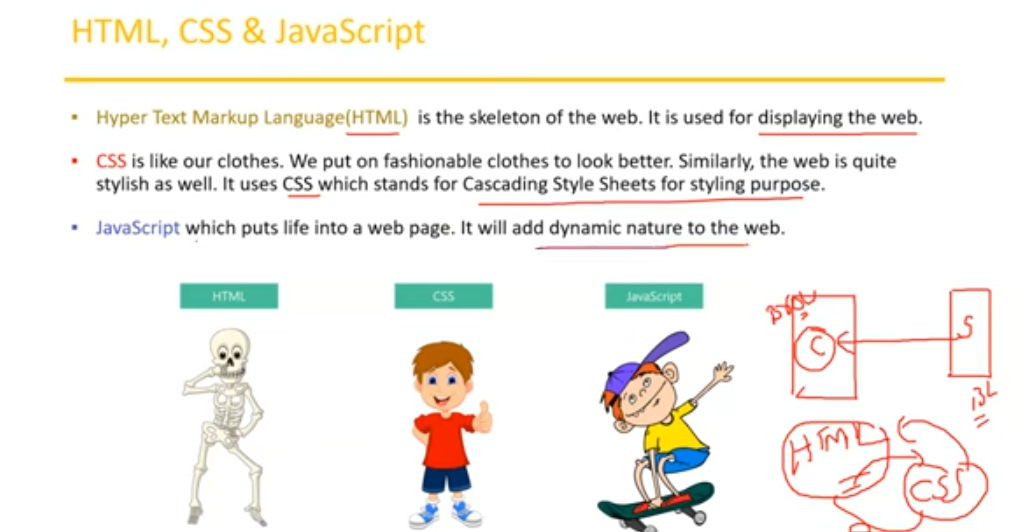

# JavaScript

## Default scripting language within HTML

## Powerful client-server scripting language which makes your webpage more lively and interactive.

## Add some dynamic nature to web pages.

## Case-Sensitive.

## Reduce load on server as some operation.

# History

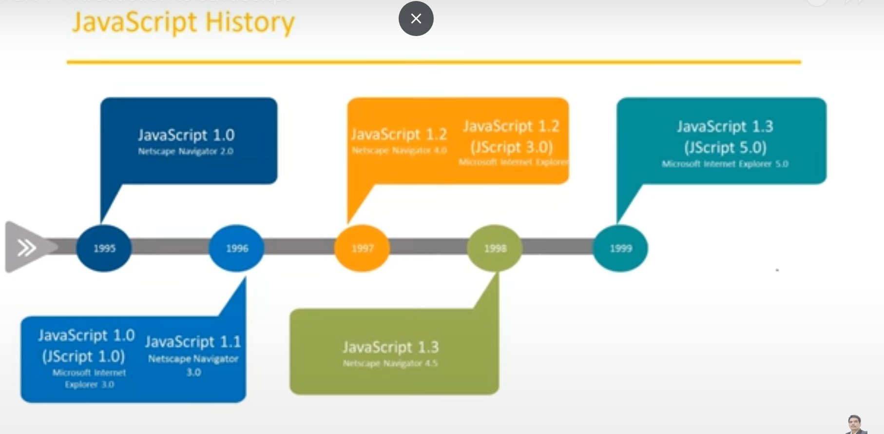

# Difference between java and JavaScript

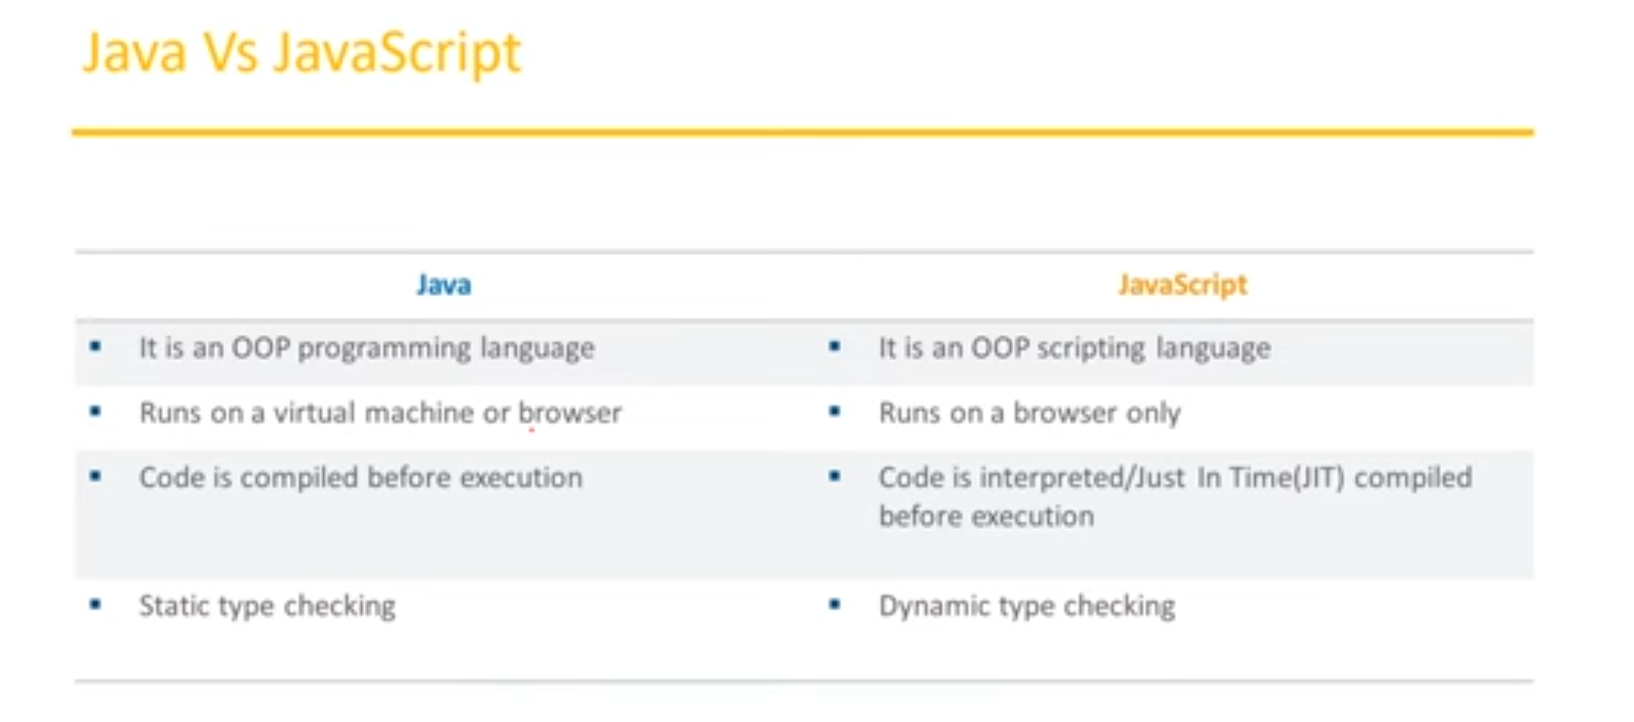

# DOM

## Document Object Model.

## Web page contains multiple elements. These elements can be created by HTML language. All these elements combinedly call HTML Document elements.

## JavaScript provides default object called document using that we can access the elements present on web page.

## HTML can create button; text boxes etch but if I want to perform any action like click on the button then by using JavaScript, we must do that(by writing script by access the element).

## JavaScript cannot understand HTML also cannot directly talk with HTML to access the elements.

## For that, At the time of loading (when we load the web page) automatically DOM structure will be created by browser based on HTML Document.

## DOM is the view of the same HTML document/file.

## Now JavaScript can understand the DOM structure to access the elements.

## Every tag in the HTML will be considered as one node in the DOM.

## Every node in the DOM can be considered as object in the JavaScript.

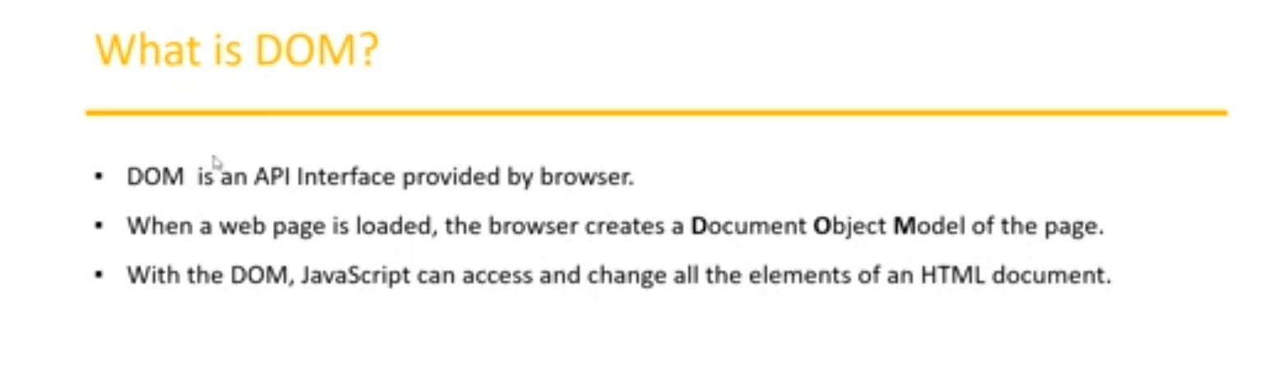

## We can see every HTML tag is created as node in DOM.

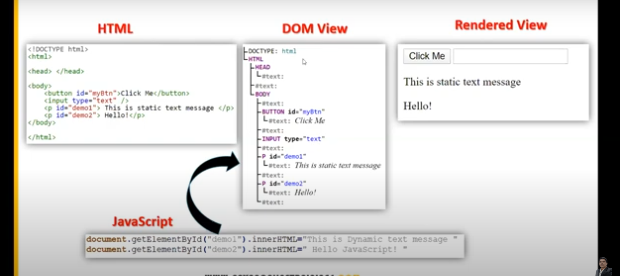

## DOM structure will be created based on the HTML by the browser during run time.

## JavaScript use that DOM structure to interact/access with elements.

# Basic HTML Code and Page

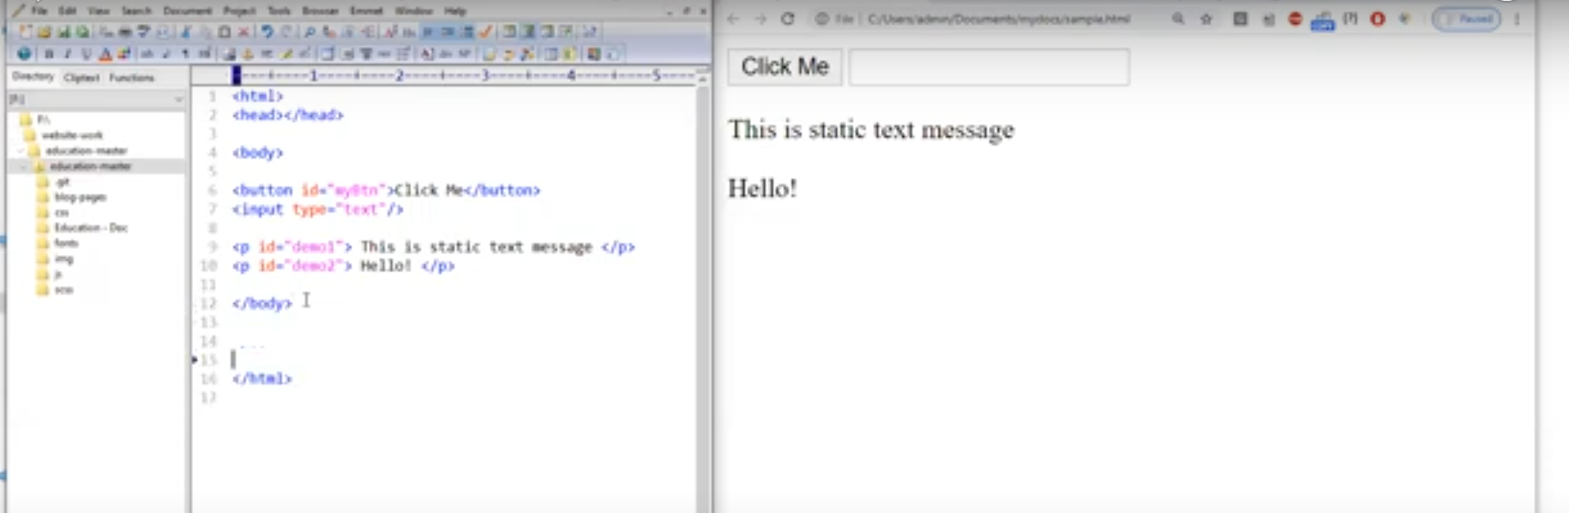

## Now we must add some dynamic actions to the elements.

## To add dynamic nature, we must **embed JavaScript into HTML**.

## So, there is a tag called **script,** add this tag after the HTML body tag.

## Inside the script tag we can write the JavaScript statements by which we can interact and change the behavior of elements dynamically.

## Using **document object,** we can get the HTML elements.

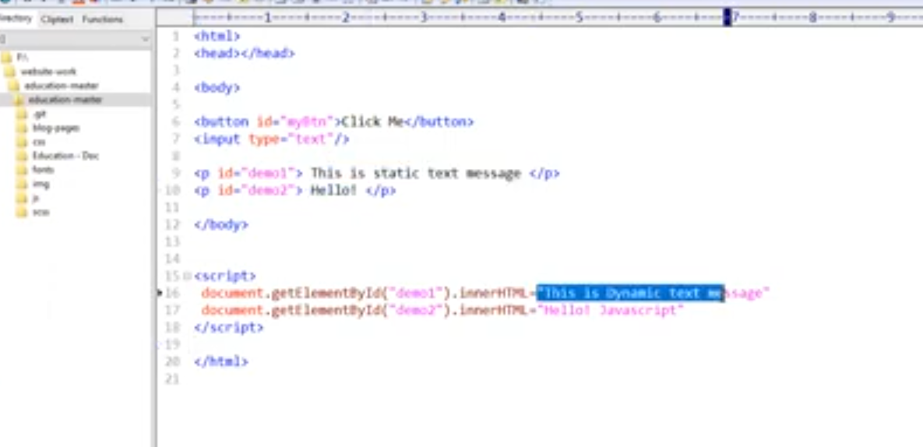

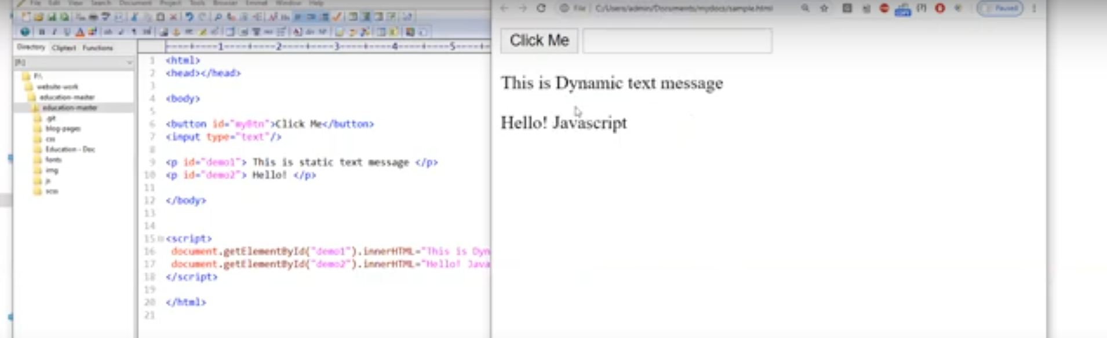

# If perform click it will display date code

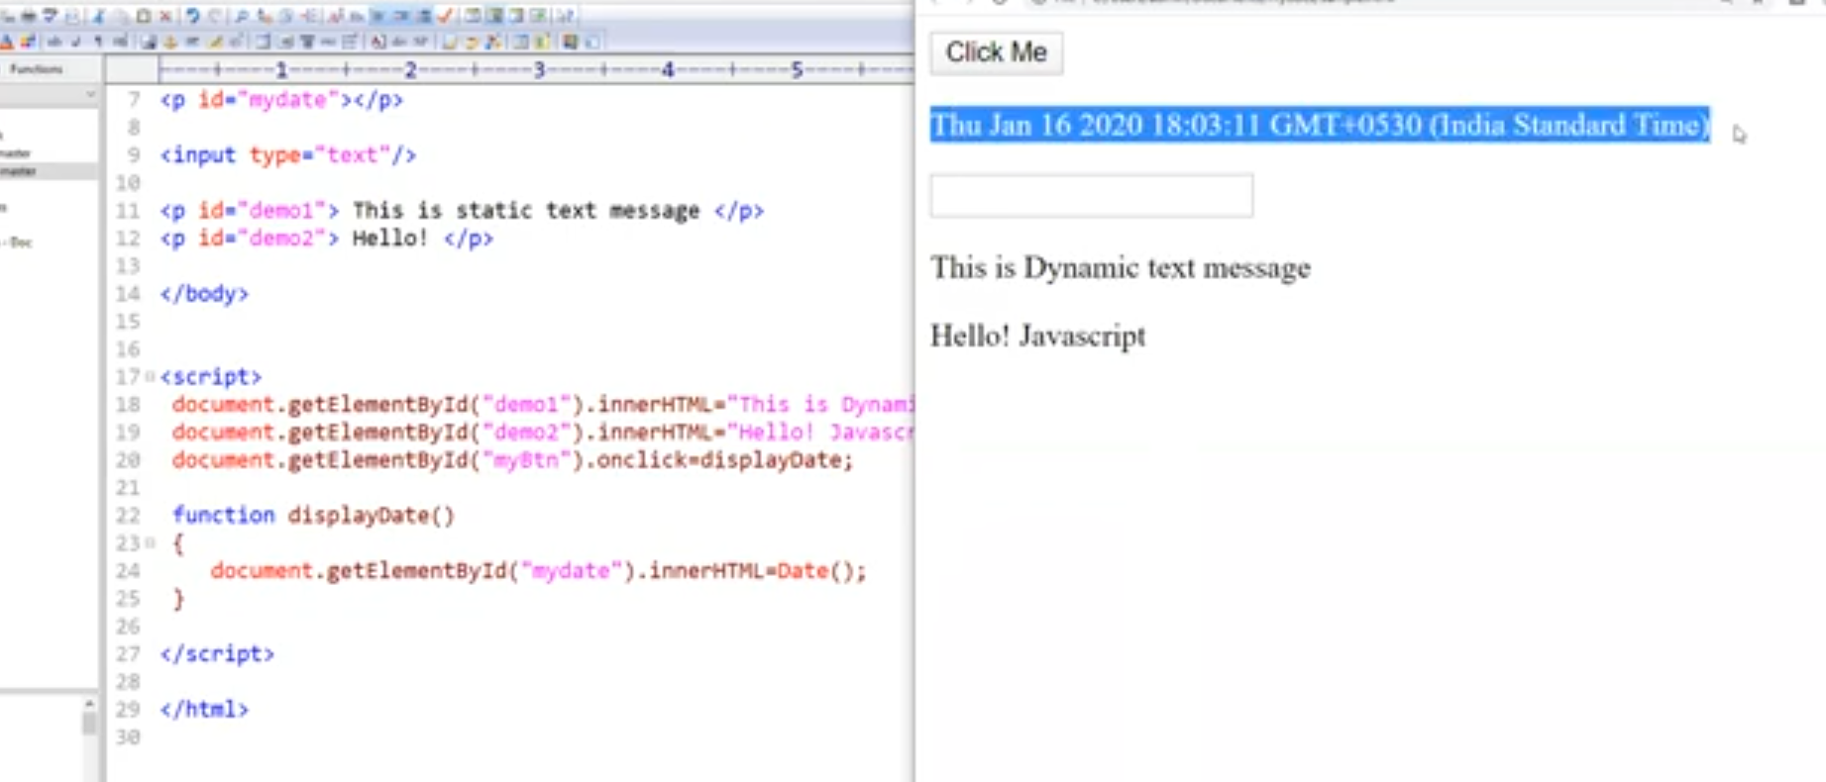

# Separate JavaScript File

## We can also create JavaScript in separate files and link with HTML.

## But script tag will be present in HTML.

## In script tag we must pass the path of our JavaScript file in **src** attribute.

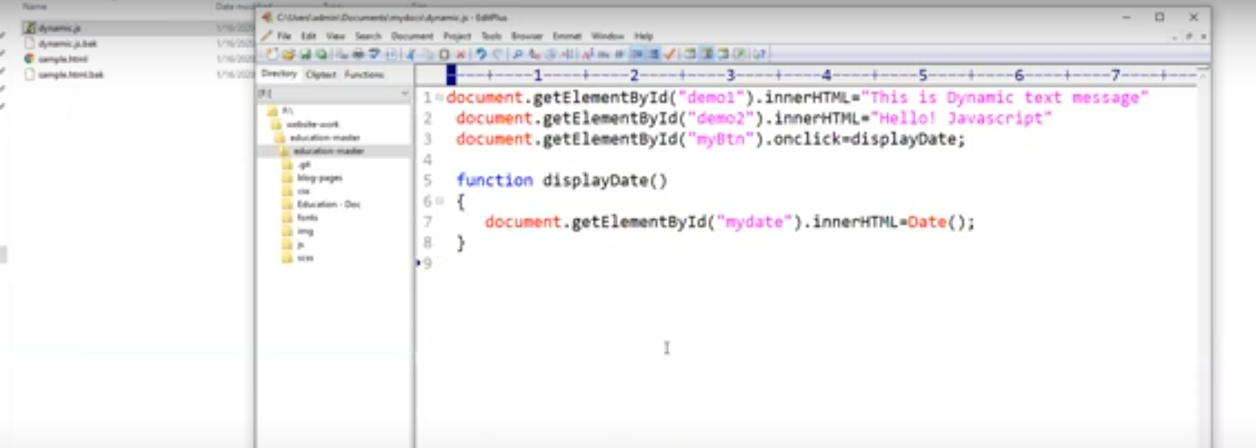

# JavaScript Advantages

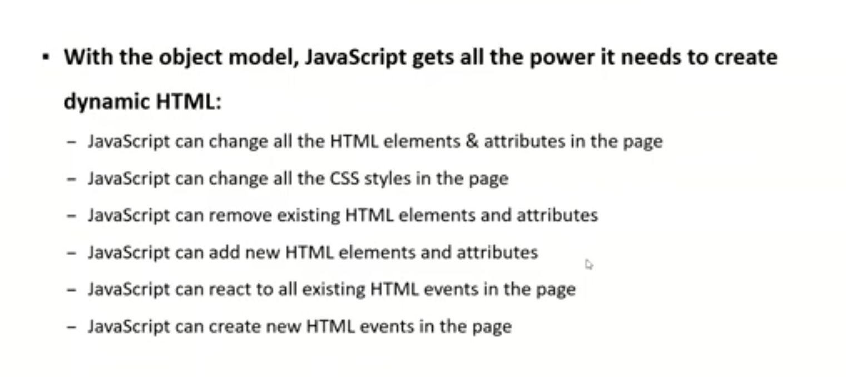

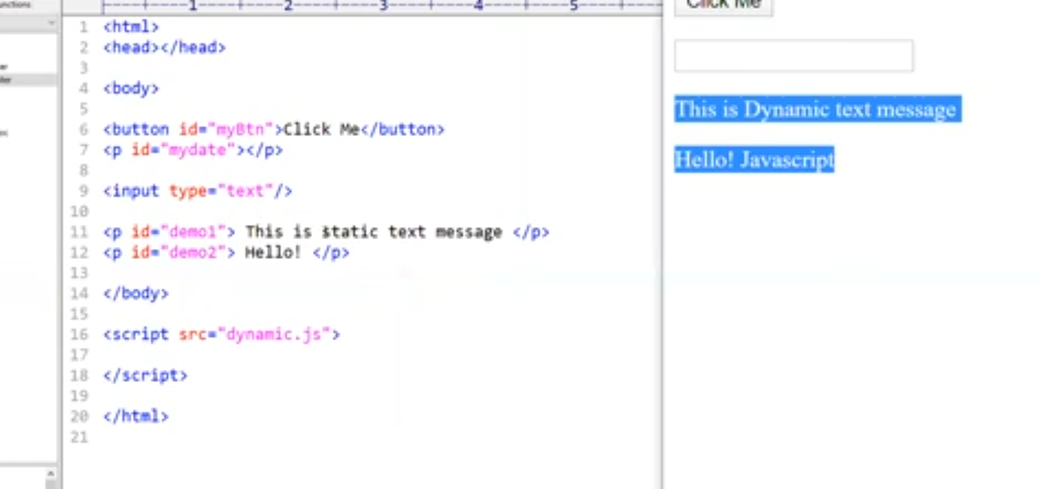

# Visual Studio Code

## To write JavaScript and HTML code many prefer to use VS code in market.

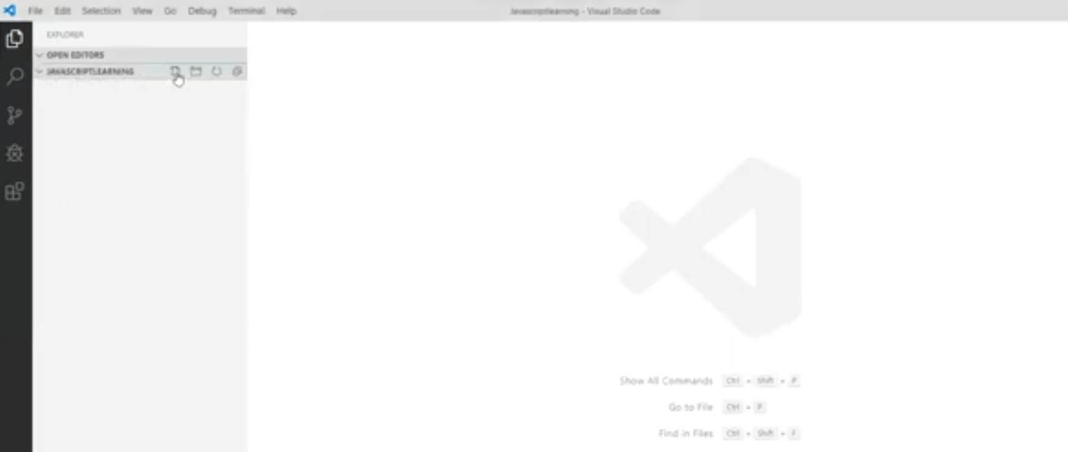

# Live Server

## The reflect the changes written in the code immediately we can install liver server to view it instead of always going to the location of HTML doc and opening.

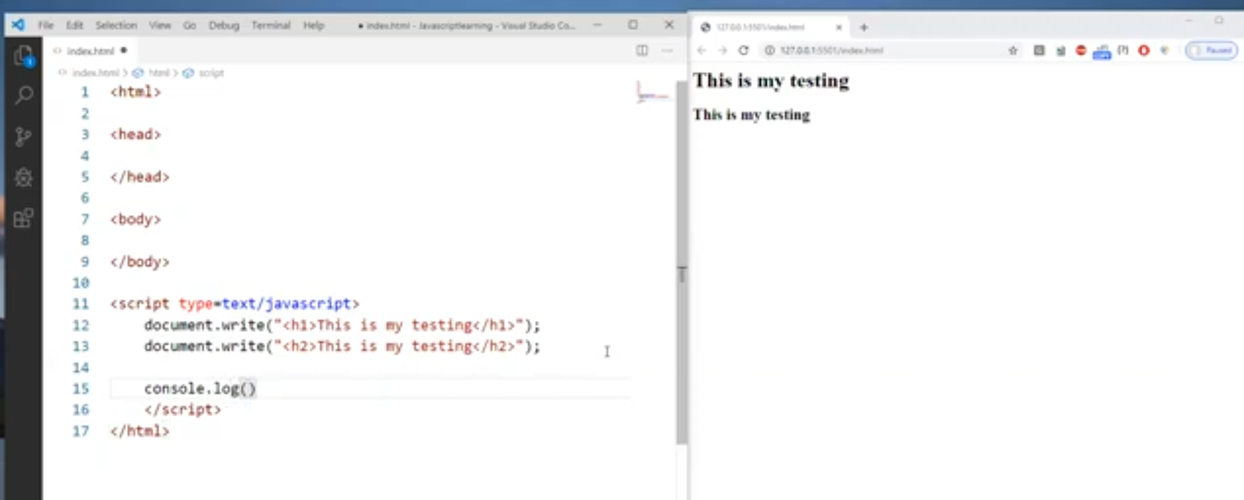

# console

## This is also one of the objects which is provided by JavaScript. It has method called log().

## Before writing anything on the HTML document or web page we can see our output in console. To check everything work fine.

## All the console messages can be seen in the browser console.

# Comments

## During runtime JavaScript will ignore those statements.

# Single line comment

## put inside //

# Multiline comment

## /*put inside this

## */

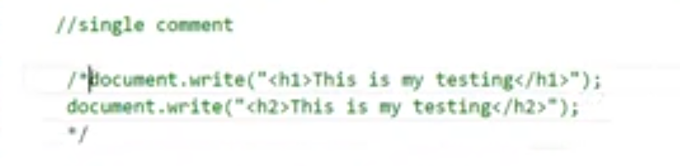

# Variables

## Container to store the data.

## Every time when we create variable it will allocate certain some memory where the data to be stored.

## We don’t want to explicitly mention the data type of the variable, JavaScript in built can take care based upon the value we pass.

## In JavaScript there are different engines like ES5, ES6, ES7, ES8 . These are different version.

## Until ES5 version we use var to store variables.

## From ES6 version they introduced two more keyword to represent variables.

## Var, we have few disadvantages. So, to overcome that they introduced let and const.

# Keywords to define the variable:

## var

## let

## const

# const

## Once you specified the value in const keyword its value cannot be changed.

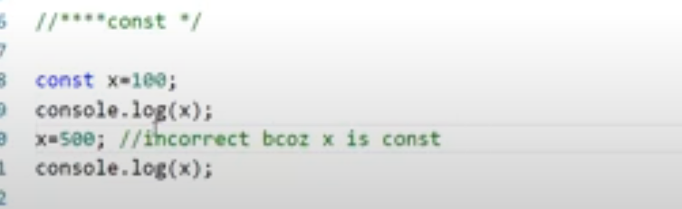

# var

## Used for variable declaration in JavaScript.

## It is function scoped.(if you don’t apply in function level then it will applied in global)

## Even if you don’t initialize the variable and try to access, it will show **undefined**.

## We can re-declare and re-assign variable with var keyword.

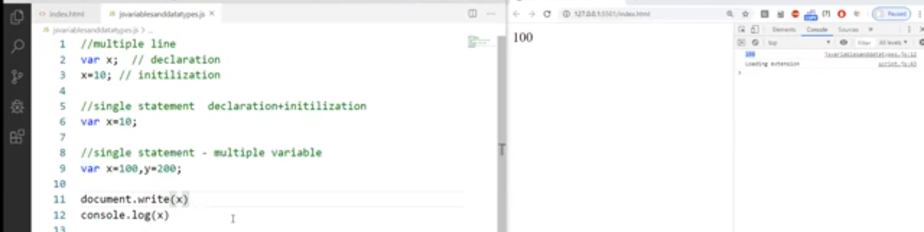

# let

## Used for variable declaration in JavaScript.

## It is block scoped.

## If you don’t initialize and try to access, then it will throw the error.

## We cannot redeclare variable with let keyword.

## Re-assigning is allowed.

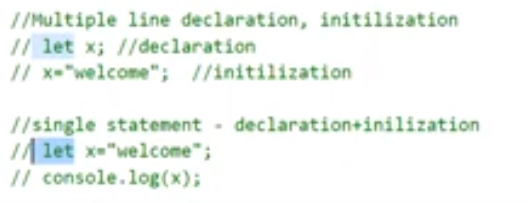

# Difference

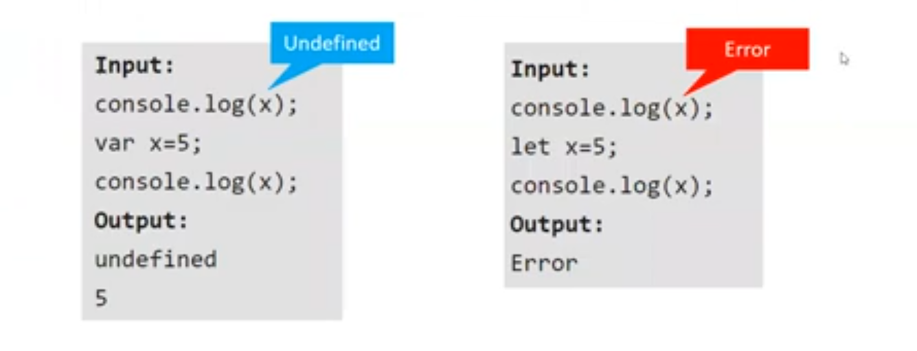

# Datatype

## Refers the type of data we store into a variable.

## We don’t need to specify the data type explicitly.

## What kind of data we are assigning to the variable by default that data type will be associated or added to that variable.

## JavaScript is dynamically typed language.

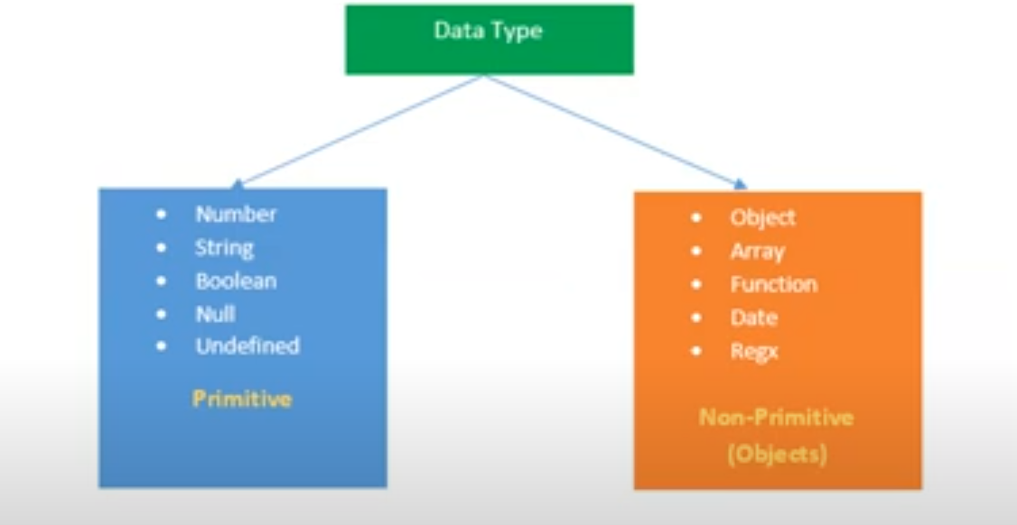

# typeof()

## This method is used to get the data type of the variable/value(data) we stored in the variable.

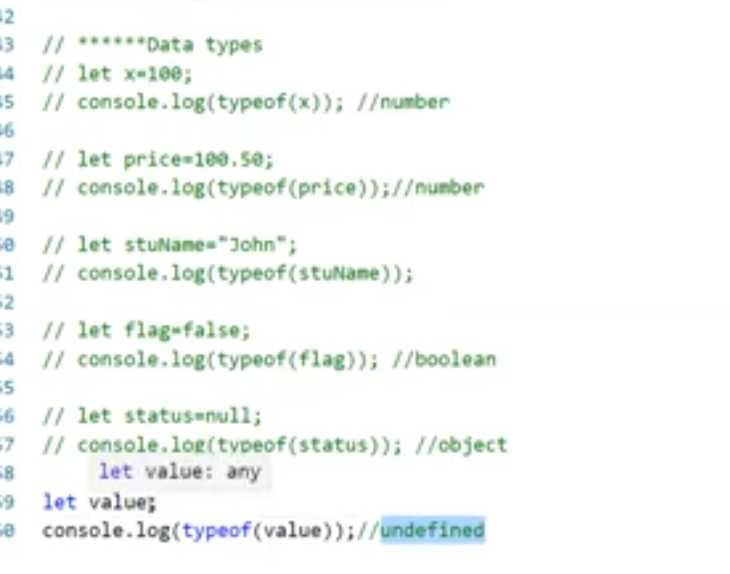

# Difference between null and undefined

## If we assign null to the variable that variable will be considered as an object

## If we assign undefined or didn’t assign anything to the variable, then that variable will be considered as undefined.

# Operators

## Symbol which performs certain operation.

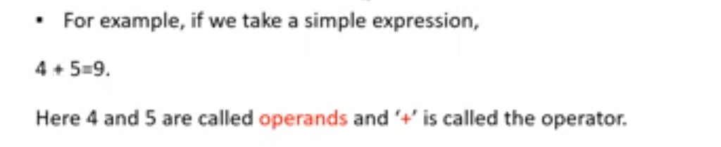

# Types

# Arithmetic Operators

## Perform mathematical operation.

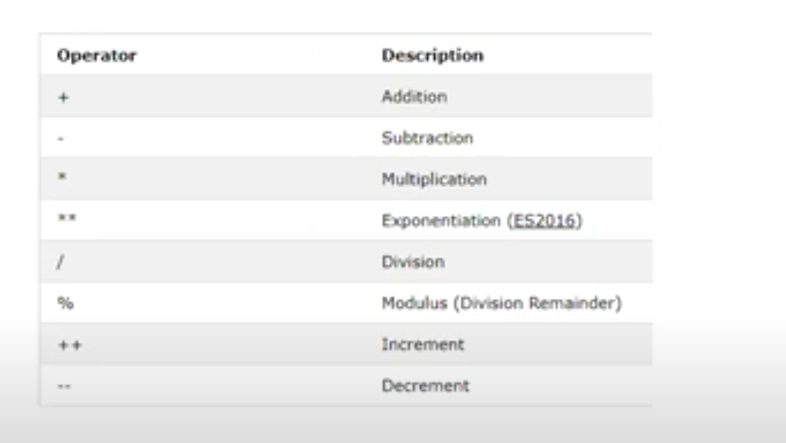

# %

## This gives you the remainder.

# /

## This gives you the quotient.

# 5**2- Exponential

## Equals to 5 square 2.

# ++(Increment Operator)

## x=x+1(x++) or(Post Increment)

## ++x(Pre-Increment)

# --(Decrement Operator)

## x=x-1(x--) or(Post Decrement)

## --x(Pre-Decrement)

# Assignment Operators(Expression Operator)

## Assign some values into other variable.

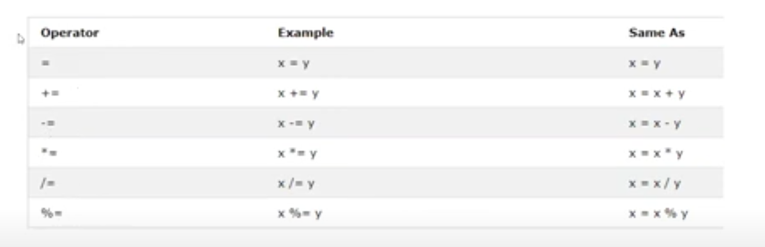

# Comparison Operator(Relational Operator)

## To Compare two or more values.

## Always return Boolean values.

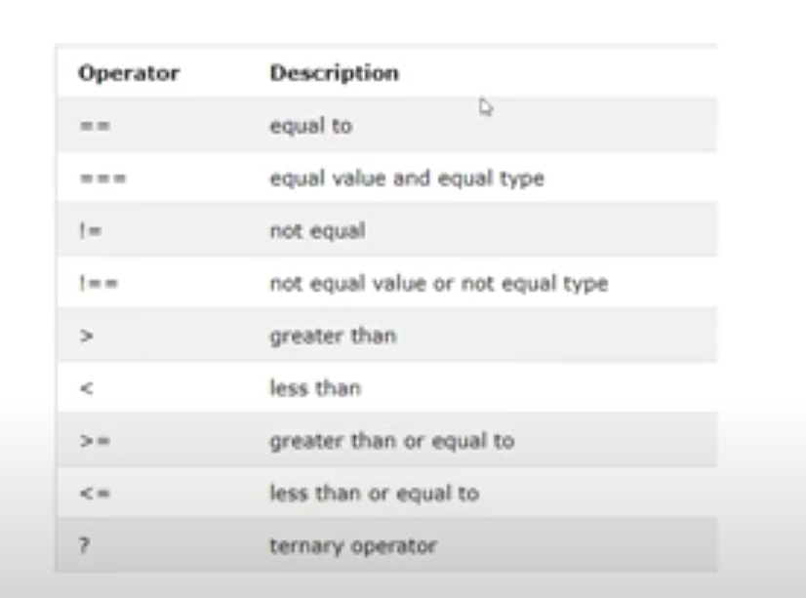

# Ternary Operator

## **Console.log(x>y?x:y)**

## Before question mark**(?)** we must put one condition using relational operator. If that specified condition is true, then it returns x if condition is false then it returns false.

# Logical Operator

## Use between two different Boolean values.

## It will be used between two Boolean values.

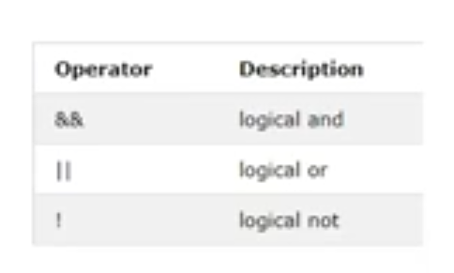

# To execute JavaScript

## Once you install NodeJS then we get a node. Using that node, we execute JavaScript file directly.

## We can see that output in console window without having browser.

## In Vs code terminal we can execute the JavaScript file by using **node command**.

# Control Statements

## Control execution order of program.

# Conditional Statements

## If we want to execute certain number of statements based on the certain condition

## If the condition is true execute one statement

## If condition is false execute another statement.

# Types

## If

## Else if

## Switch case

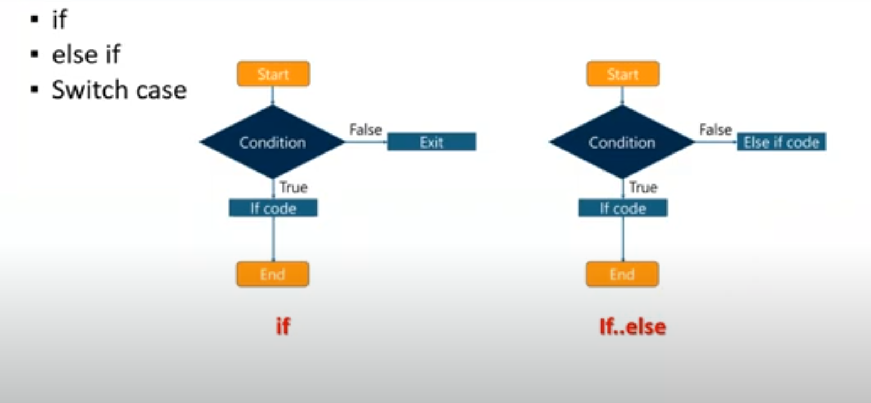

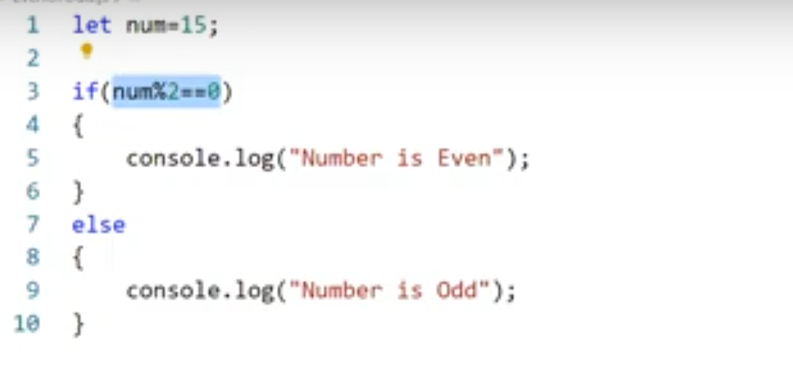

# Nested if else statement

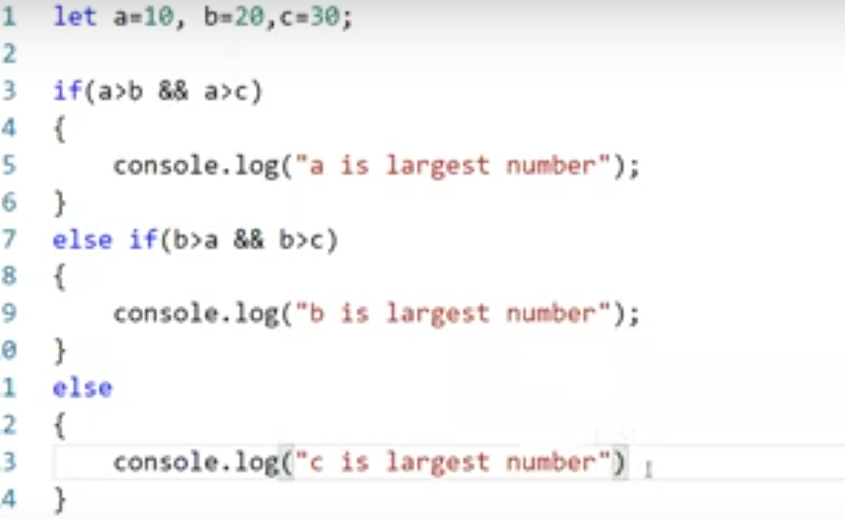

# If else ladder

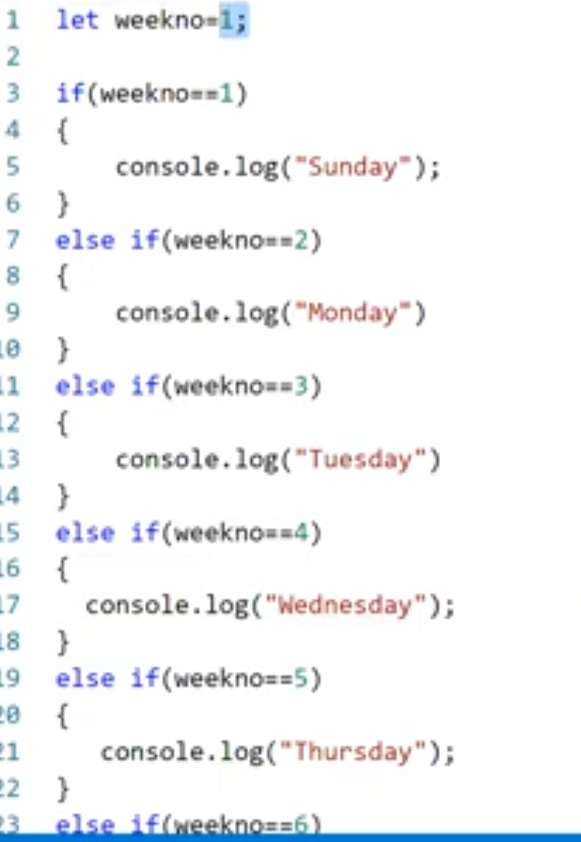

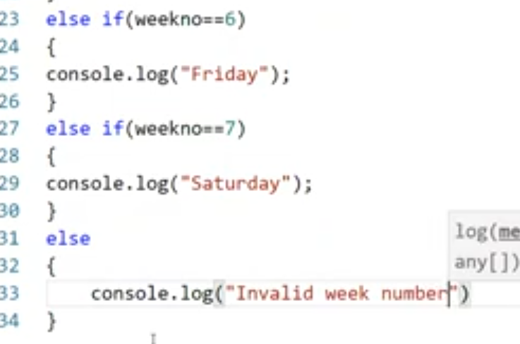

# Switch Case

## Used to reduce our code if we have more, number of conditions.

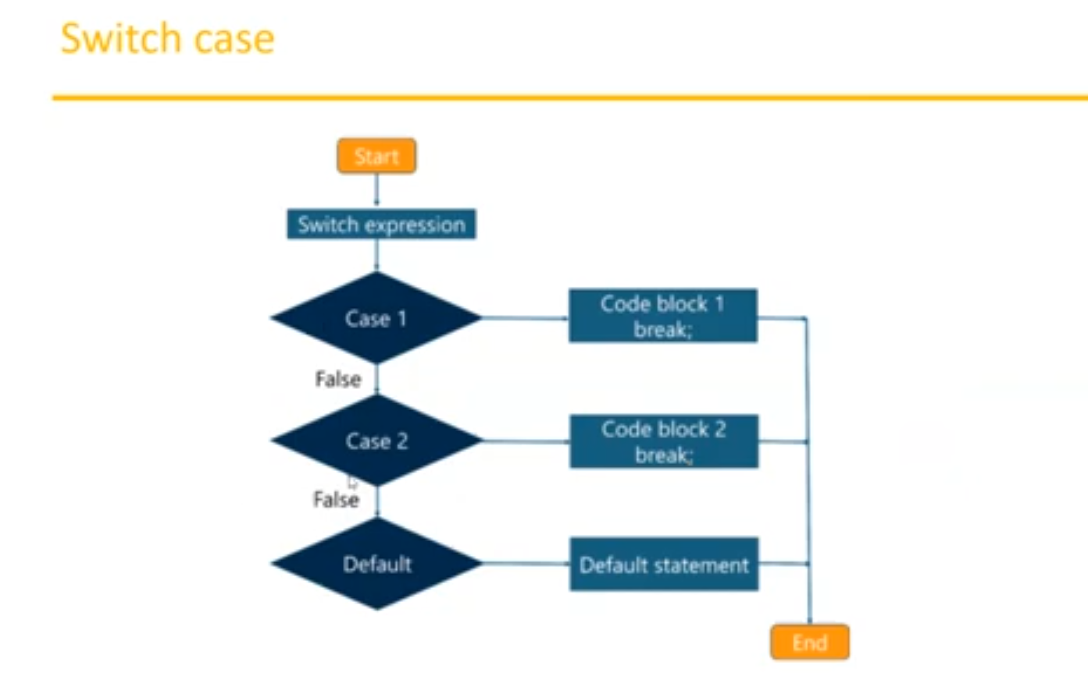

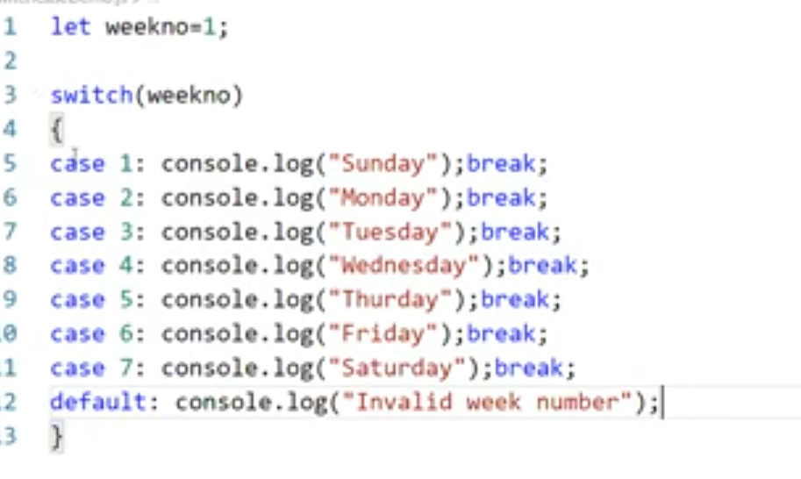

# Looping Statements

## Suppose we want to execute same set of statements multiple times repeatedly then we create a loop and repeat multiple times until it reaches certain conditions.

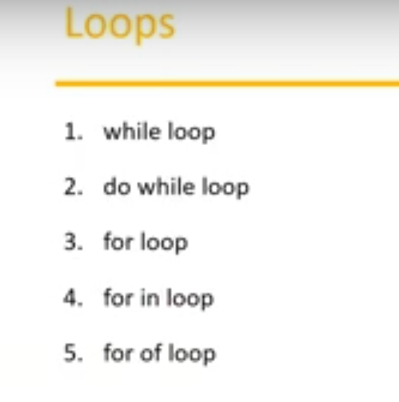

# While loop

## First it will check the condition and then enter the block. Without satisfying the condition it never enter the block.

## While loop will not execute any statement until or unless the condition is satisfied while first entering.

## Used to repeat a section of code an unknown number of times until a specific condition is met.

## Basically, you should write one condition and the loop should have some code which can manipulate(i=i+1) the variable given in the condition(i<10).

## If you want to repeat the loop based upon some condition, then use while loop.

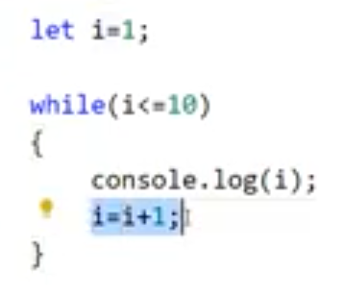

# Even Number

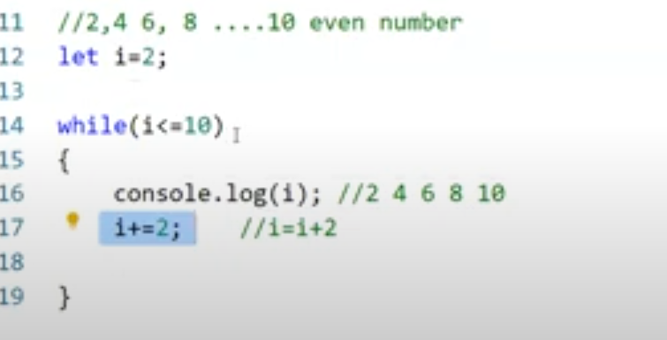

# Descending Order

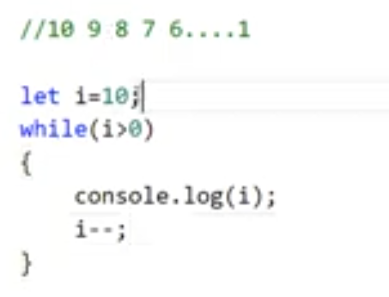

# do while:

## First time it will not verify any condition directly it will jump into the statement and then verify the condition.

## The statement will be executed at least once even though the condition is not satisfied.

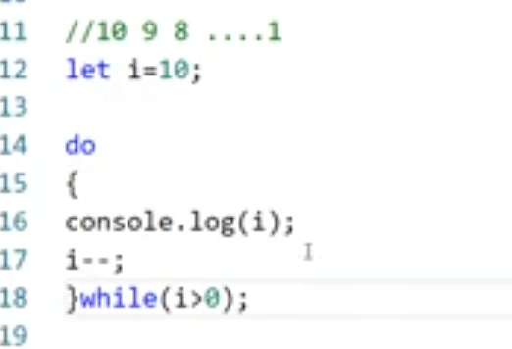

# for loop

## Reduce the code.

## Initialization, condition and increment in same line.

## When we know how many times, we have to run the loop then use for loop.

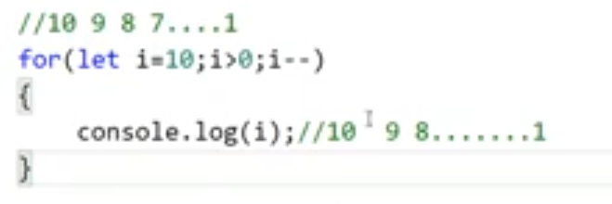

## Common multiple values of 2 and 5

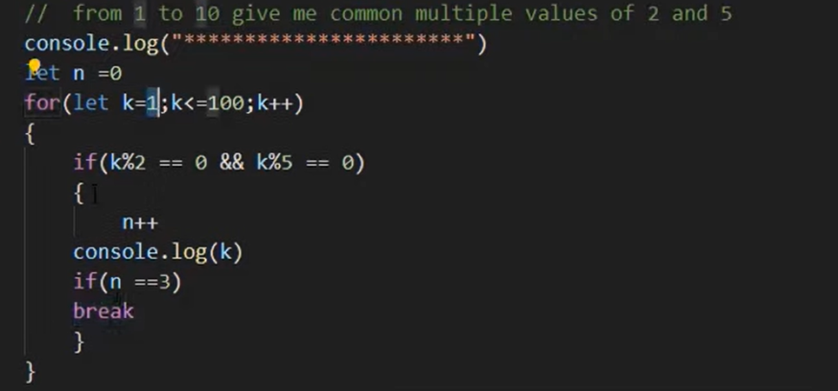

# Sum of the array elements

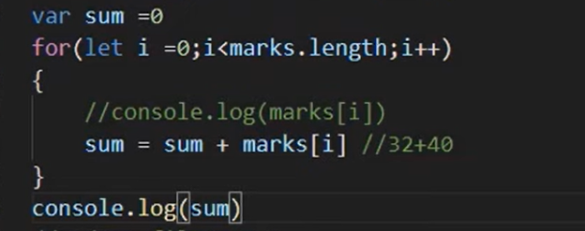

# Jumping Statements

## Suppose when we execute the program based upon certain condition we want to jump into the next level or to next statement or exit from the program.

# break

## Come out from the loop.

## Terminates the current loop or switch statement and transfers program control to the statement following the terminated statement.

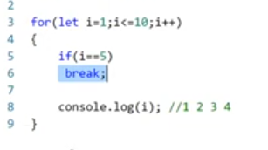

# continue

## Terminates execution of the statements in the current iteration of the current or labeled loop and continues execution of the loop with the next iteration.

## Skip that values and continue with next values.

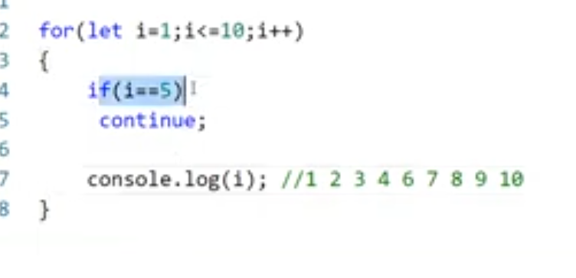

# Functions

## Block of statements which will perform a specific task.

## Parameters are optional. Sometimes the function takes the parameter sometimes not.

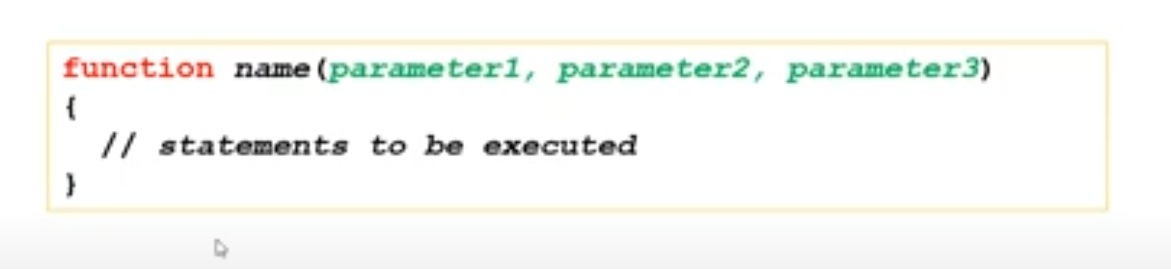

# Why functions?

## Reuse code

## We can use the same code many times with different arguments to produce different results.

# Function invocation

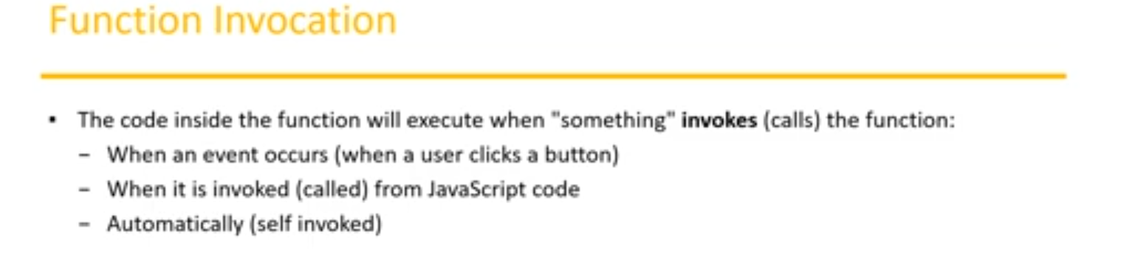

# Function with parameter without return statement:

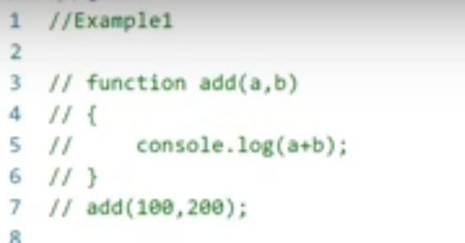

# Function with parameter with return statement

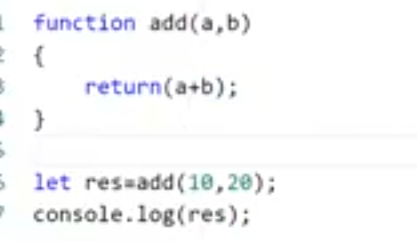

# Function without parameter without return statement

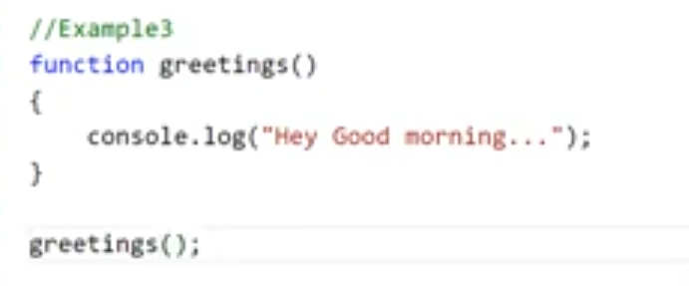

# Function without parameter with return statement

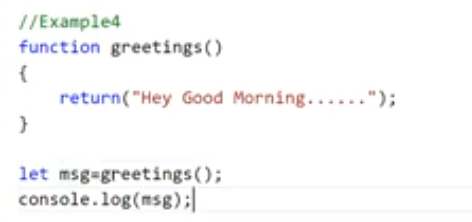

# Function example

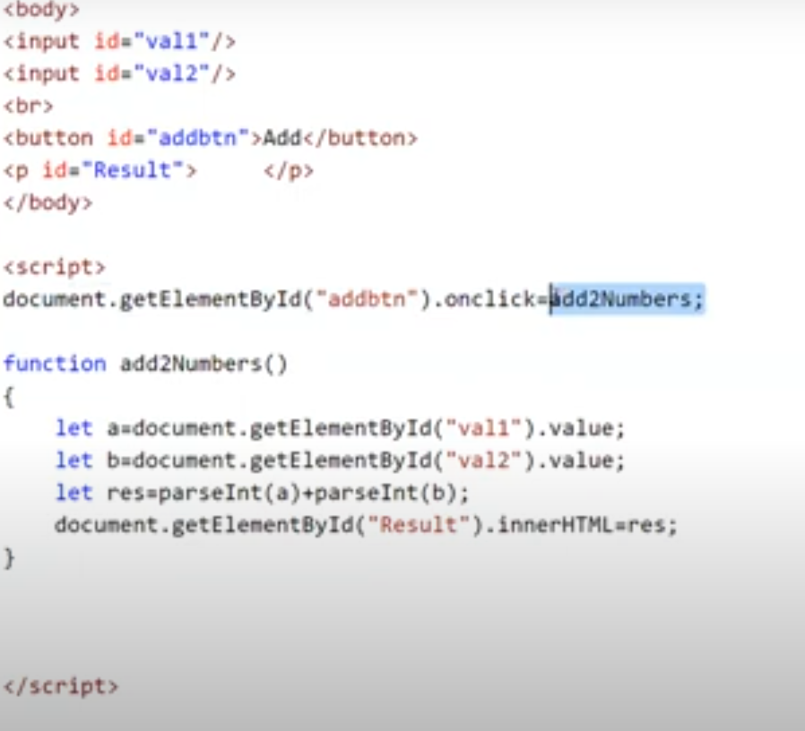

# parseInt()

## Convert text format into number format.

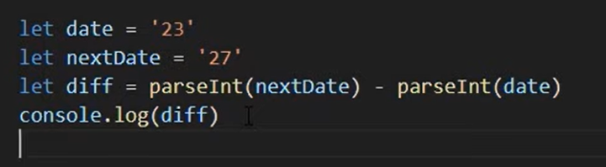

# Function Definitions

## JavaScript functions are **defined** with the **function** keyword.

## You can use a **function declaration** or a **function expression**.

# Function Declarations

# Approach 1:

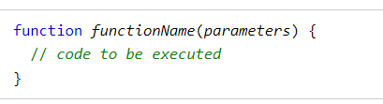

# Approach 2: Function without name but with function keyword

# Function Expressions

## A JavaScript function can also be defined using an **expression**.

## A function expression can be stored in a variable.

## After a function expression has been stored in a variable, the variable can be used as a function

## The function above is actually an **anonymous function** (a function without a name).

## Functions stored in variables do not need function names. They are always invoked (called) using the variable name.

## Anonymous function only can be assigned to variables.

## We can send arguments/parameters by using the variables itself.

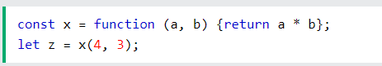

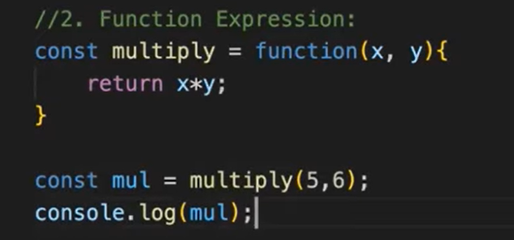

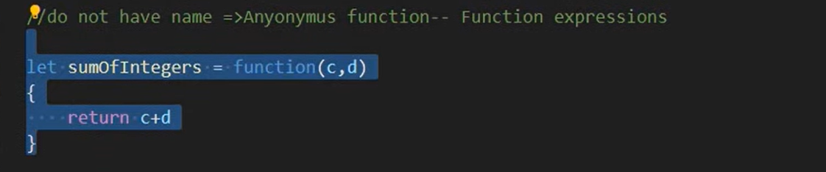

# Approach 3: Function without name and no function keyword

# Arrow Function

## It is concise way of writing JavaScript functions in shorter way.

## They make our code more structured and readable.

## **Arrow functions** are anonymous functions i.e. functions without a name but they are often assigned to any variable. They are also called **Lambda Functions**.

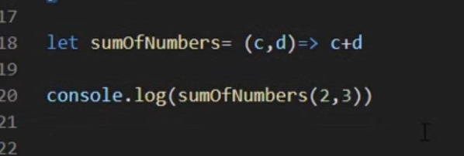

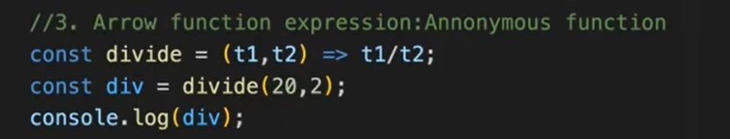

# Approach 4: Function Constructor

## It is used to create a new function object using the Function() constructor with the new operator.

## It creates a function that has a global scope.



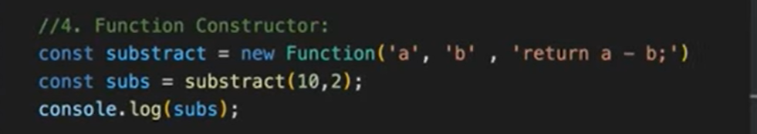

# Approach 5: Immediately Invoked Function Expressions

## Immediately Invoked Function Expressions (IIFE) are JavaScript functions that are executed immediately after they are defined.

## They are typically used to create a local scope for variables to prevent them from polluting the global scope.

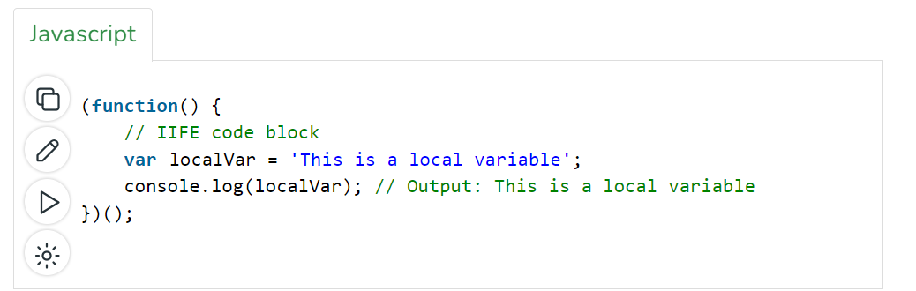

# Approach 6: Function Generator

## A generator-function is defined like a normal function, but whenever it needs to generate a value, it does so with the yield keyword rather than return.

## The yield statement suspends the function’s execution and sends a value back to the caller, but retains enough state to enable the function to resume where it is left off.

## When resumed, the function continues execution immediately after the last yield run.

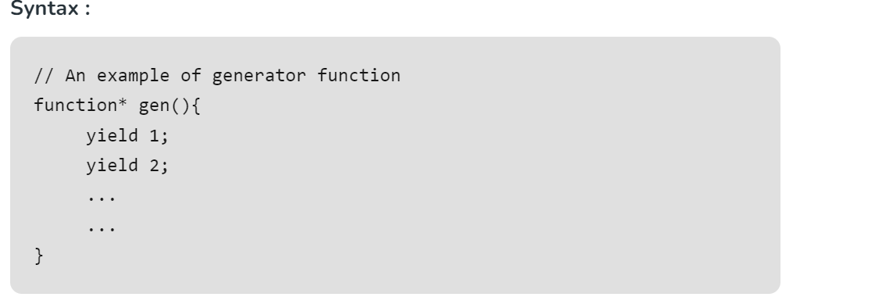

# Approach 7: Anonymous Function

# 

# Approach 8: Recursive Function

## Recursion is a programming technique where a function calls itself repeatedly to solve a problem.

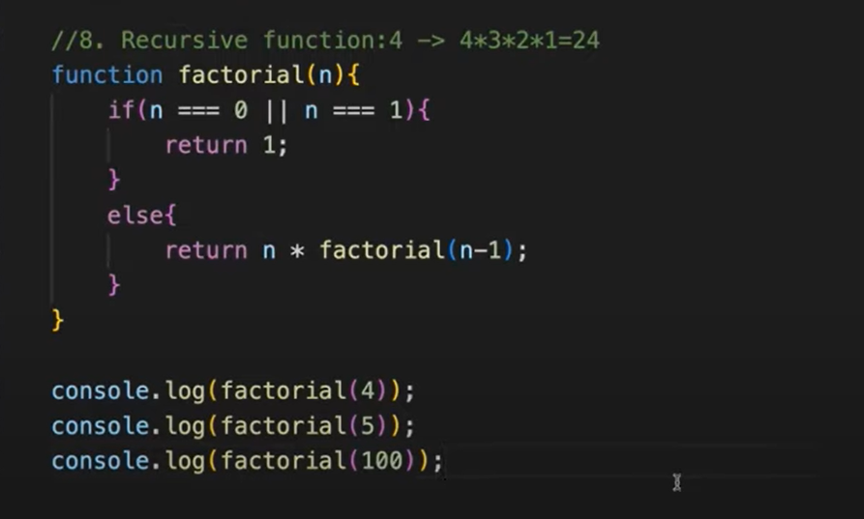

# Approach 9: High-Order Function

## It is a function that can accept other functions as arguments, return functions, or both.

## They enable abstraction, composition, and the creation of more flexible and reusable code.

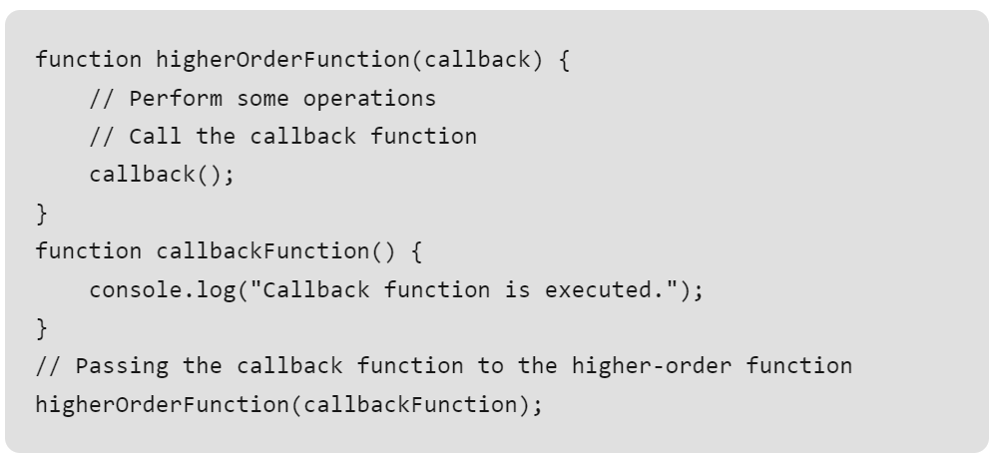

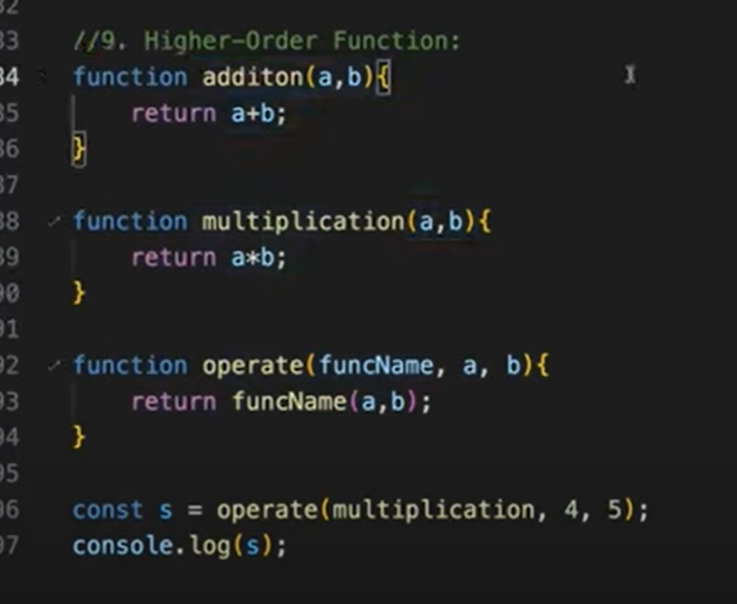

# Arrow Function

# Single Parameter

## If we have one parameter, it is not mandatory to put open close brace.

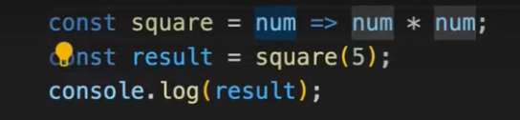

# No Parameter:

## blank bracket is mandatory.

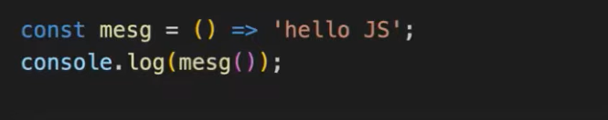

# More than one parameter: Bracket is mandatory.

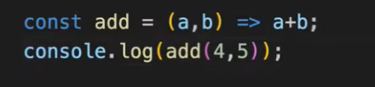

# Using Objects

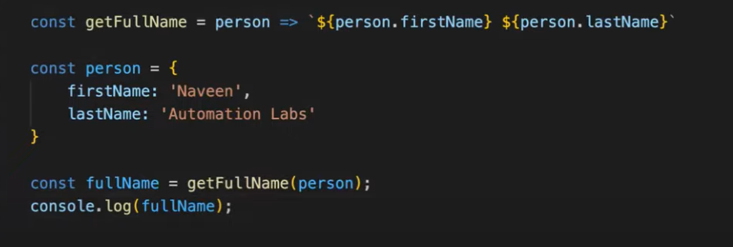

## If no parameters, then print Hello text.

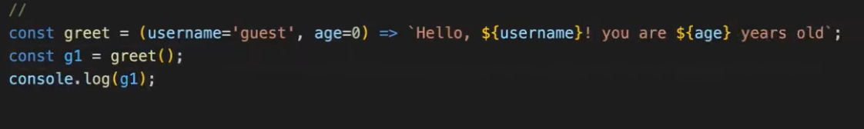

## If passing parameters, then print parameter values instead of Hello

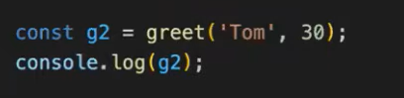

# Rest parameters

## Allowing us to more easily handle various inputs as parameters in a function.

## The rest parameter syntax allows us to represent an indefinite number of arguments as an array.

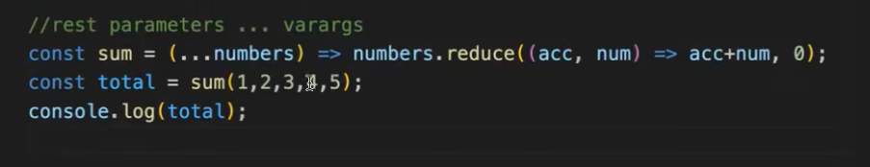

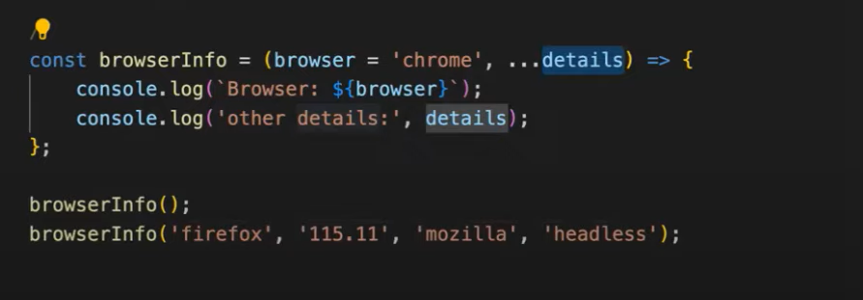

# Max number

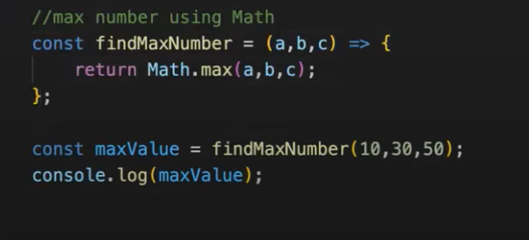

# JavaScript Objects

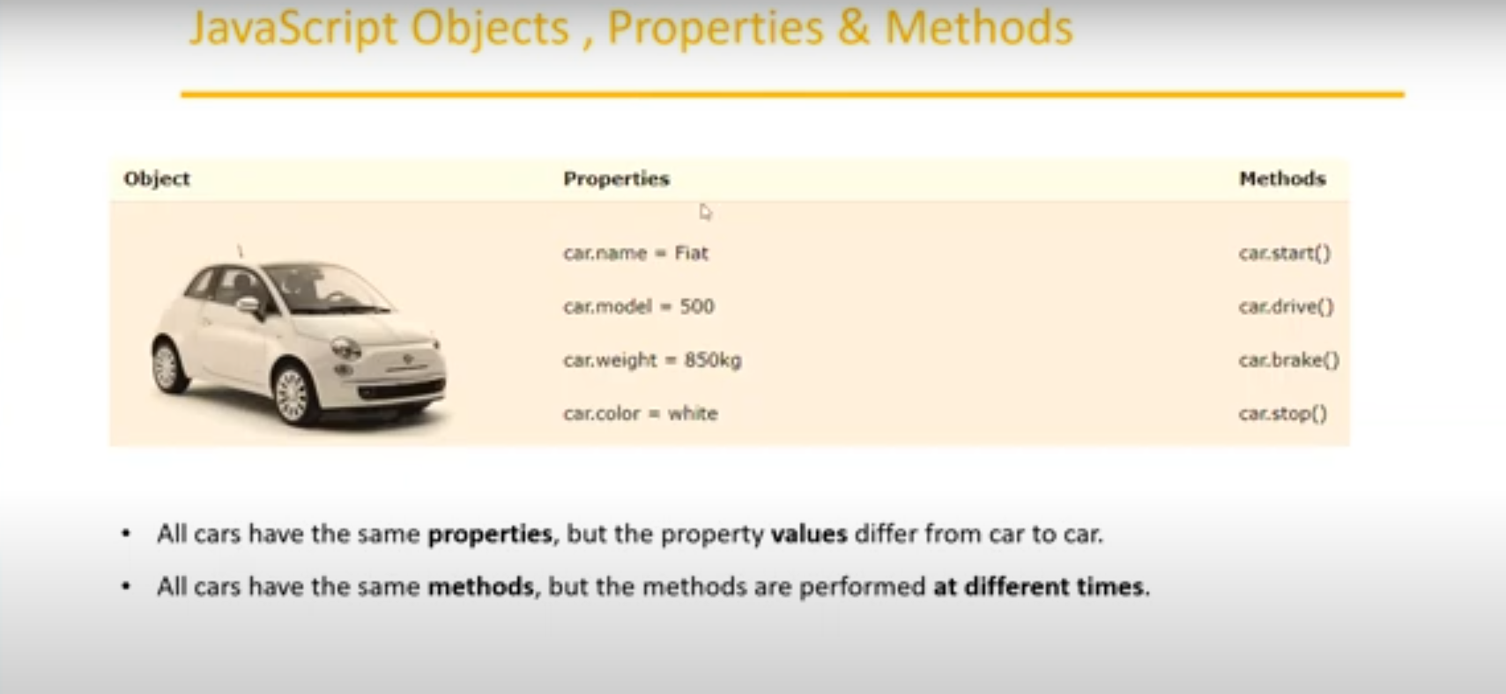

## Object is an entity which contains certain number of properties and methods.

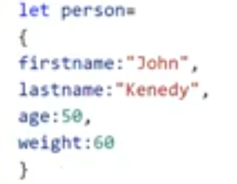

## person is the object which contains different properties and values in it.

# Accessing Object Properties

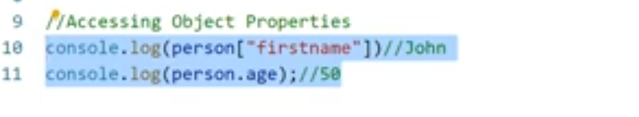

# Adding new properties into object

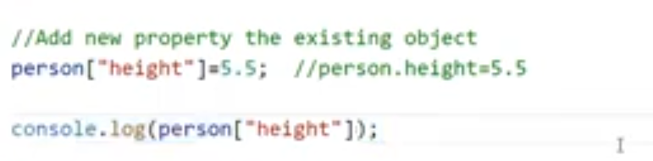

# Updating existing property in the object

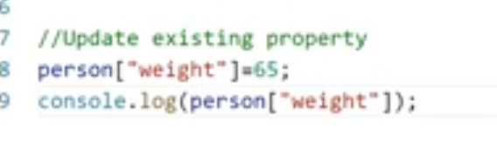

# Remove the property from the object:

## Use delete keyword to delete the property.

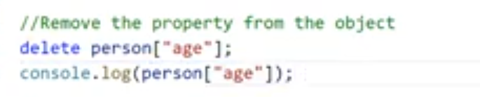

# To verify the property is present inside the object:



# To print all values of java script objects.

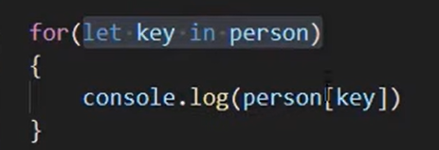

# Capture property name without value using for in loop

# If we want to read the properties one after another we use “for in” loop

## It will capture only the property name not the value.

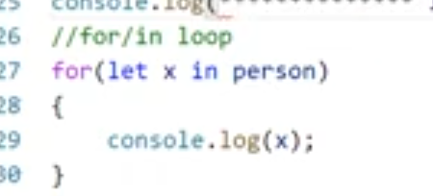

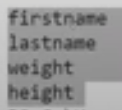

# Capture property value

## Use object name to access the value as below:

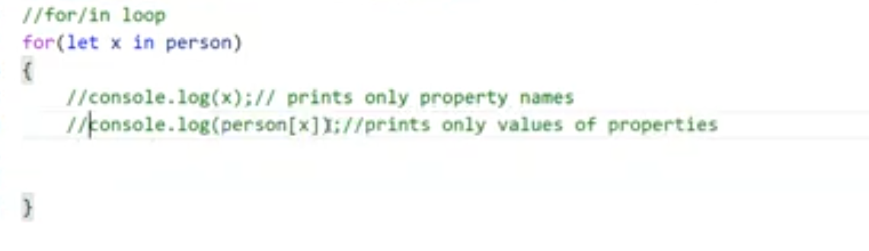

# Combination of property and value

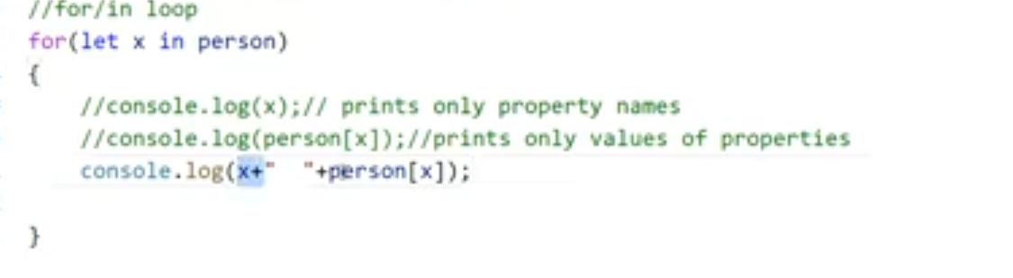

# Creating Objects and functions

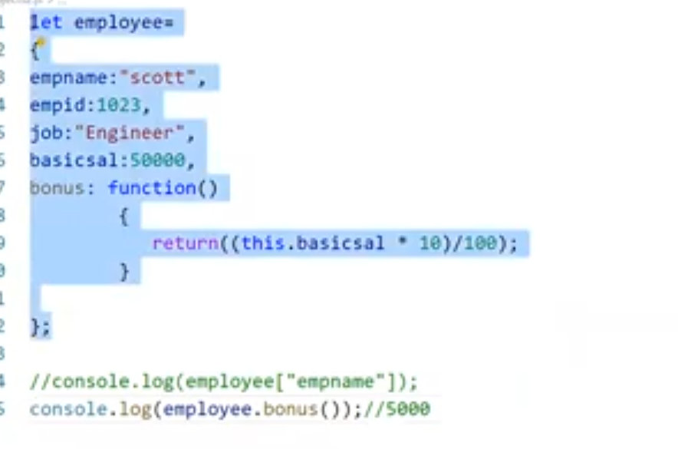

## To access anything within the function use **this** keyword. This represents the object.

## To Access function (employee.bonus()).

# Arrays

## If we have set of values then we can store all them in container called array.

## To store multiple values into single variable.

## Array itself is an object in JavaScript.

## It will return object.

# Declare Array in two ways

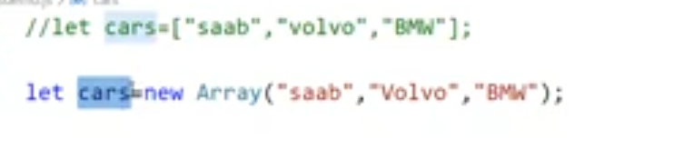

## I will internally allocate locations for the values. Every location is representing index number. Index starts from 0.

## The last index will be n-1.

# To access the element

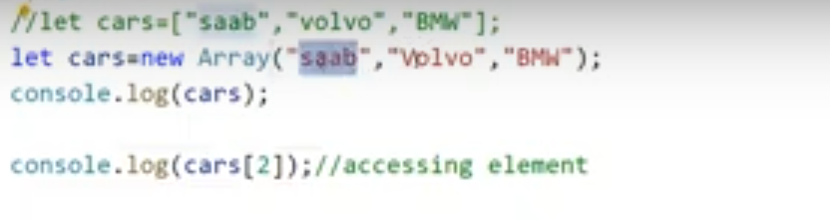

# To change the array value

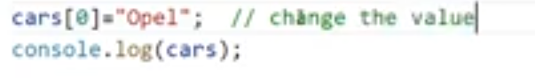

# Storing different types of data

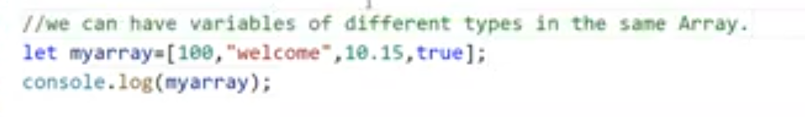

# To store objects within the array

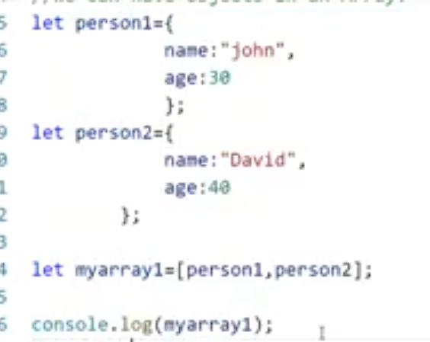

# To access the array values

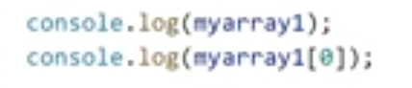

# To find the length of an array



# To read the data inside array

# Using for loop

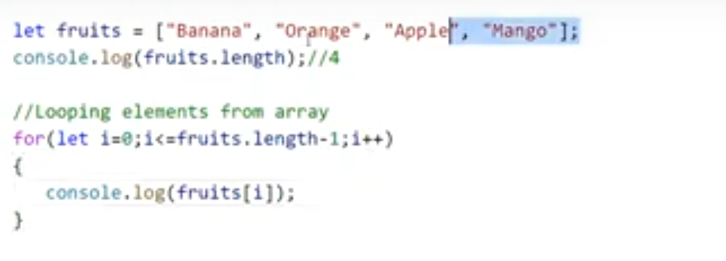

# Using for of loop

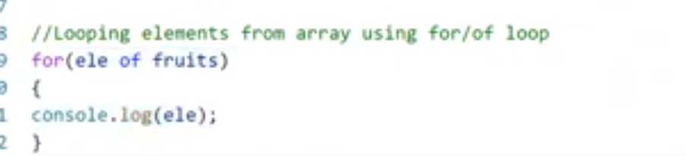

# To recognize whether the variable is array or not:

# Approach 1:

## Use typeof method.

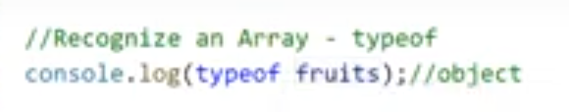

# Approach 2:

## Array is a predefined object in JavaScript.

## Use isArray() method to check the variable is array or not.



# Array Methods

# Example



# toString()

## Converts an array into String by separating the values using comma.



# Join()

## Same as toString method. Same output

## We have flexibility to specify how we can separate the values by any kind of special character.



# Pop()

## Removes the last element from the array.

## It will also return the value of removed element.

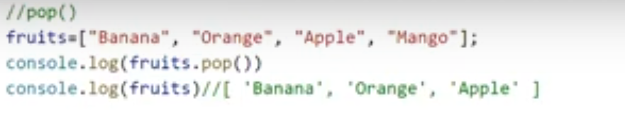

# Push()

## Add new element to the array at the end of the array.

## Append new elements to an array.

## Also, it will return the length of new array.

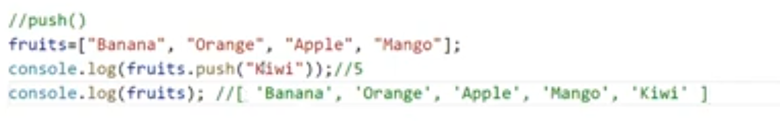

# Evenscores push into new array:

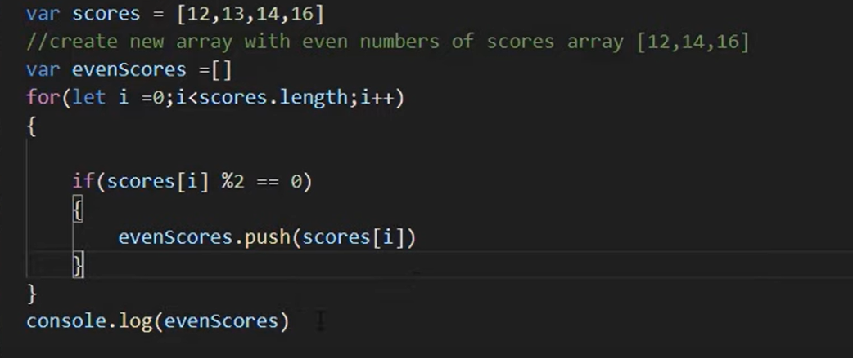

# Shift()

## Removes the first array element and shifts other elements to lower index.

## It also returns the removed element.

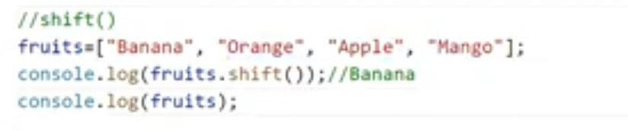

# unshift()

## Add new element at the first index (beginning) and shifts other element to higher index.

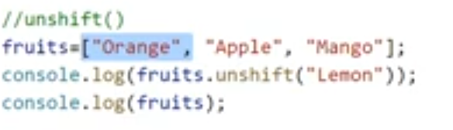

# Delete element from array:

## Element is removed but the memory allocated for that element still remains.

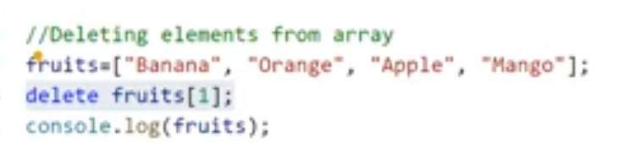



# Concat()

## We can join or merge two or more arrays.

# Join example.

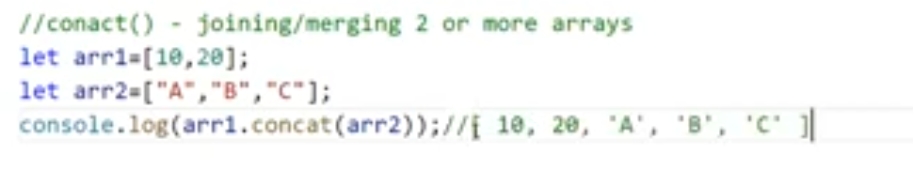

# Merge Example

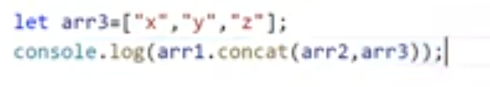

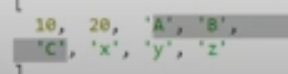

# Slice()

## Gets some portion(elements) of the array depends upon the index we pass from there rest of the element will be returned.

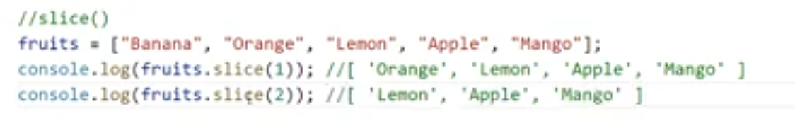

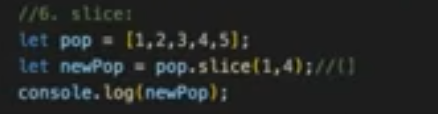

# Sort()

## Sort the element from array.

## **String** – Alphabetical Order

## **Number** – Ascending Order

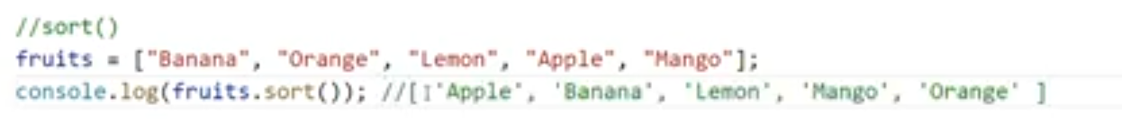



# Reverse()

## Reverse the array. It will change the original array order.

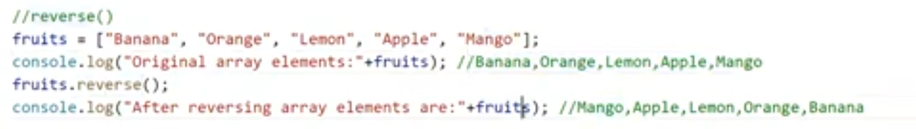

# Splice()

## Allow to remove specific elements(any count) from the specified index and add new element on the same index(place).

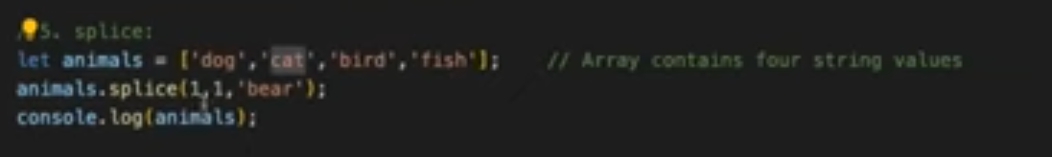

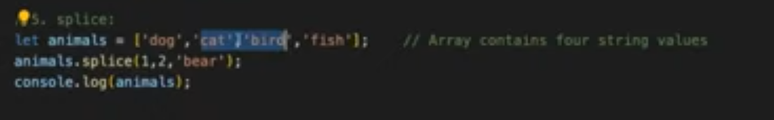

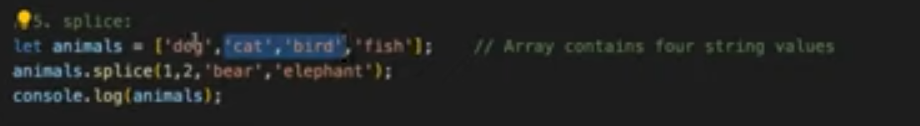

# indexOf()

## Returns the index of specified element.

## If duplicate elements are present, it will return first element index.

## If that particular element is not available, then it will return -1.

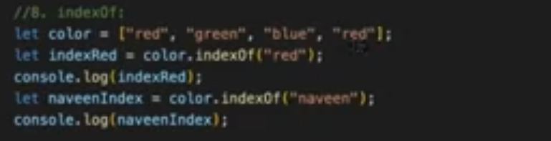

# Checking the occurrence of day in the array

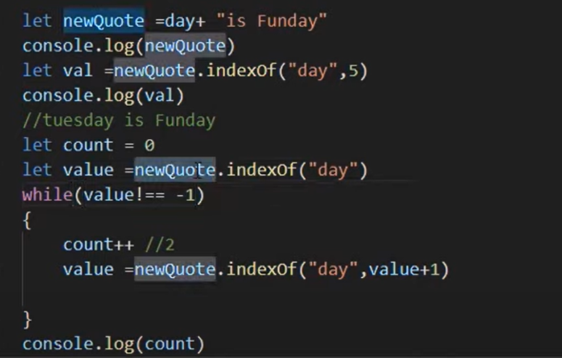

# Return second occurrence of index if duplicate.

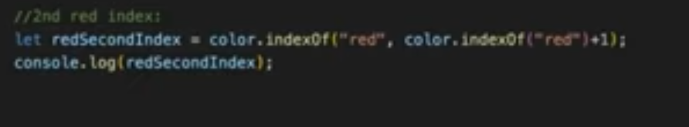

# lastIndexOf()

## returns the last index (position) of a specified value.

## returns -1 if the value is not found.

## starts at a specified index and searches from right to left (from the given postion to the beginning of the array).

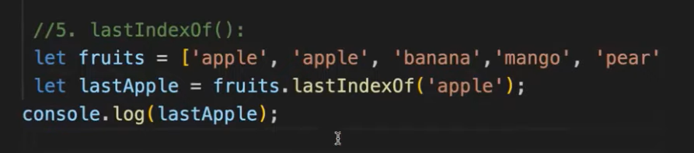

# Includes()

## To check whether the specified element is included inside the array.

## It returns true or false.

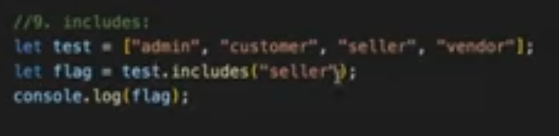

## Even any one of the elements available it will return true

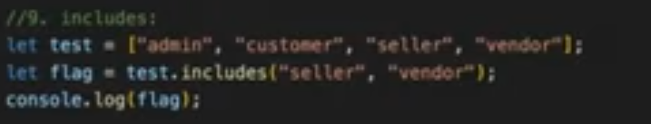

# Reduce()

## If we have any concept where we want to iterate and update values.

## It always returns a single value, so the reduce() method iterates over the values defined in your array and reduces them into a single value.

## Inside the callback function of the reduce() method, you can do any kind of operation you need to achieve a certain result, such as summarizing and grouping certain values, or removing duplicates.

## This is done with the help of the “accumulator”, which stores the value returned from the previous iteration.

## You set the initial value of the accumulator by passing a second argument to the reduce() method.

# When to Use the reduce() Method

## Summarizing your values into a single value

## Grouping similar items together

## Removing duplicates from an array

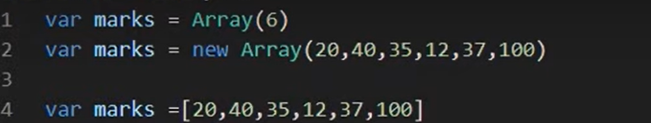

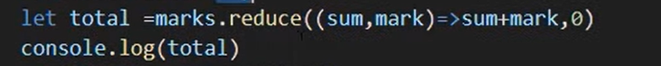

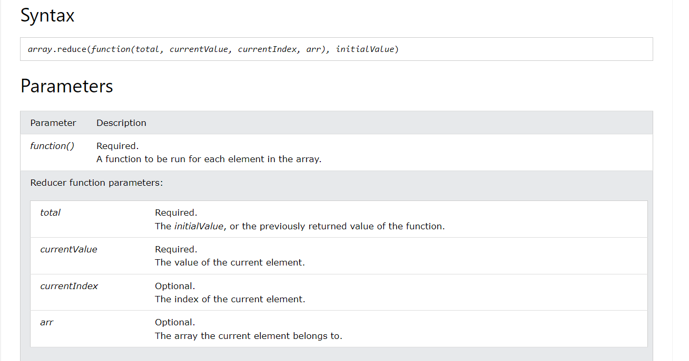

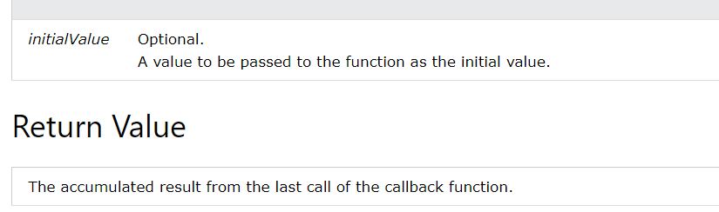

©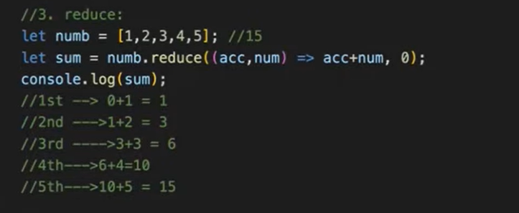

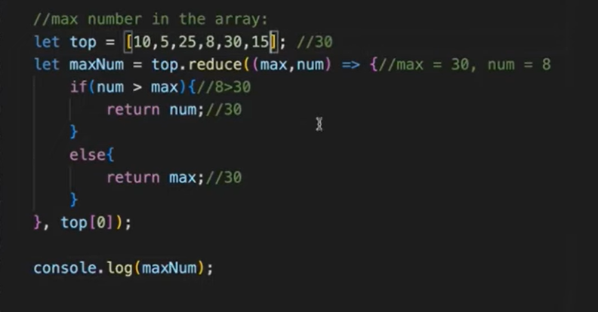

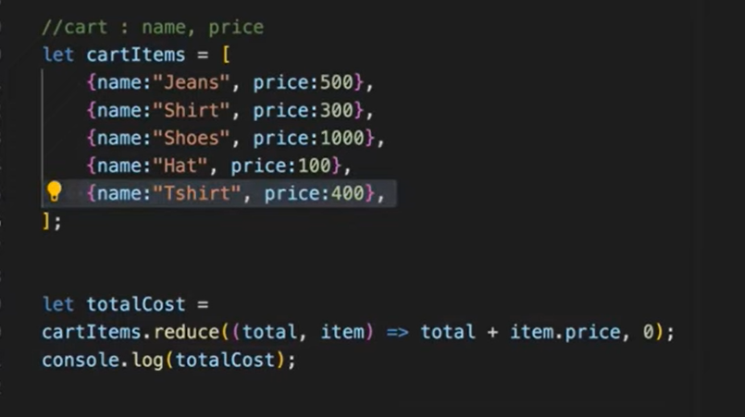

<https://www.freecodecamp.org/news/how-to-use-javascript-array-reduce-method/>

# Filter()

## It creates a new array filled with elements that pass a test provided by a function.

## It does not execute the function for empty elements.

## It does not change the original array.

## If we want to filter the array based on some conditions, then use filter method. Filter will return the array only when it matches the condition.

